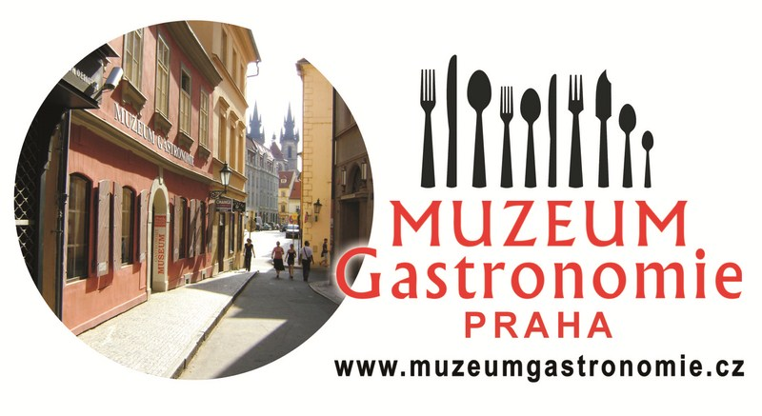
PRESS RELEASE
The Gastronomy Museum in Prague Celebrates its 1st Anniversary

Prague, 22nd May 2013
The Gastronomy Museum, the first museum of its kind in the Czech Republic, is celebrating its 1st anniversary.
The Museum's unique exposition guides visitors through the History of Cooking, from the domestication of fire up to the present day. In a traditional tavern, classic bar and wine cellar they can discover the history of the oldest and most traditional alcoholic beverages, which may then also be tasted on special guided tours. In the merchant's shop, visitors are enchanted by old vessels for food storage and the naively cute promotional posters and historical packages.
The exposition on the 1st floor is also the first of its kind, from the History of Dining and Cutlery to the Gallery of International Chefs and Gastronomes. In the Hall of Fame, Czech experts as well as the general public will be pleasantly surprised by the great and glorious history of Czech cookbooks, Gastronomy and the restaurant industry.
To quote Prof. Čeněk Zíbrt - ”If the evolution of a cuisine is a measure of human progress, and if cookery books are the milestones on this journey, then the Czechs have not lagged behind on this score. Since the 16th century, countless cookery books have been written and published, with recipes of Czech meals being spread throughout Europe. These milestones mark the rapidly growing respect for the ancient art of Czech cooking.”
What has taken place during the past year?
Since last May, the exposition of the Gastronomy Museum has been viewed by many visitors from the Czech Republic and from around the world. Among others, residents of Patagonia and the world's largest island – Greenland – have also found their way to us. Everyone, irrespective of nationality, has enthusiastically viewed the Museum and appreciated its unique theme. They all evaluate positively the artistic aspect and unobtrusive educational impact of the Museum," says Museum Curator, Nina Provaan Smetanová.
The main event on the occasion of the 1st Anniversary was the First Prague tasting of fruit distillates which was held successfully on Saturday 18th May. The main winner and holder of the Challenge Cup was Zdeněk Jelínek of the Lubná Distillery. This event will also be held in the coming years.
During the year, interesting exhibits were regularly added to the Museum. The Hall of Fame of Czech Gastronomy welcomed hotelier Antonín Brandejs, owner of the Art Nouveau Hotel Paris, along with an exceptional cake bearing the same name. As one of the first Czech protected brands, Pardubice Gingerbread (Pardubický perník) was given a place of honour as well.

Other interesting events were also held in the Gastronomy Museum. Besides the historic first evening tour by candlelight and flashlight, the Museum Retro Bar was baptised by the introduction of the Gastronomy Museum's brand new cocktail – Medový hřebík ("Honey Nail") – mixed by famous bartender Alex Mikšovic.

The Hall of Fame was the venue for the book launch of Můj divotvorný hrnec ("My Magic Pot") by one of the most famous Czech chefs, Jaroslav Sapík, and for MasterChef – Deník vítěze ("MasterChef – Winner's Diary") by Petr Jonáš, describing the development of the popular TV cookery show.

Small groups of foreigners participated in cooking lessons in the Museum kitchen, where they learnt to cook or bake a traditional Czech delicacy under expert supervision.

The guided tasting of Spanish wines and the themed guided tours including the tasting of selected spirits received a favourable response.

We welcomed a whole range of famous personalities to our Museum, for example, directors Josef Vondráček and Zdeněk Troška, and actress and producer Dana Homolová. In addition to the contestants in "Miss Princess", some other famous visitors were participants in the TOP STAR Magazine TV programme – actors Ivan Vyskočil and Lumír Olšovský, singer and presenter Petra Černocká, actress Vlasta Žehrová, singer Heidi Janků, presenter Marie Tomsová, actor and presenter Jiří Krampol, actress and painter Iva Hütnerová, opera singer Andrea Kalivodová, and writer and presenter Halina Pawlowská.

Regular visitors include school groups, from kindergartens to universities. Numerous school groups have already benefitted from interesting gastronomic facts, as well as from learning about the lifestyles of our ancestors. Experienced guides adapt the guided tours to the age and interests of the pupils. The tours for Czech and foreign schools are enriched by prepared worksheets in Czech, English and German.
During the Museum's first year, students from vocational schools regularly presented their cooking skills in the modern Museum demonstration kitchen. Visitors could admire their cooking proficiency, as well as taste the traditional Czech specialities that were the topic of the school year.

In particular, we value the collaboration with the following schools:
Kladno Secondary and Vocational School, Beroun-Hlinky Secondary and Vocational School, České Budějovice Secondary and Vocational School of Tourism, Sokolov Secondary Trade School, Vlašim Secondary and Vocational School, and the Secondary, Elementary and Nursery School for the Hearing Impaired at Holečkova 4, Prague 5.
Visitors gave an enthusiastic reception to the thematically laid tables in which, in addition to the above-mentioned schools, the U Krbu Vocational School also participated.
For the next school year, visitors can look forward to specialities from the countries of the European Union.

The Gastronomy Museum is located in the Old Town of Prague, at 12 Jakubská Street.
More information at www.muzeumgastronomie.cz

For the Press: Nina Provaan Smetanová, Curator, The Gastronomy Museum, tel.: 775291381

